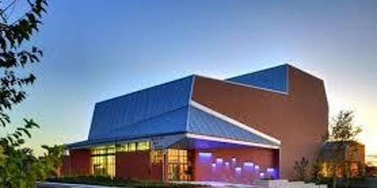

McCallum High School
Saturday, April 25th, 2026
McCallum High School Arts Center
5600 Sunshine Dr.
Austin, TX 78756

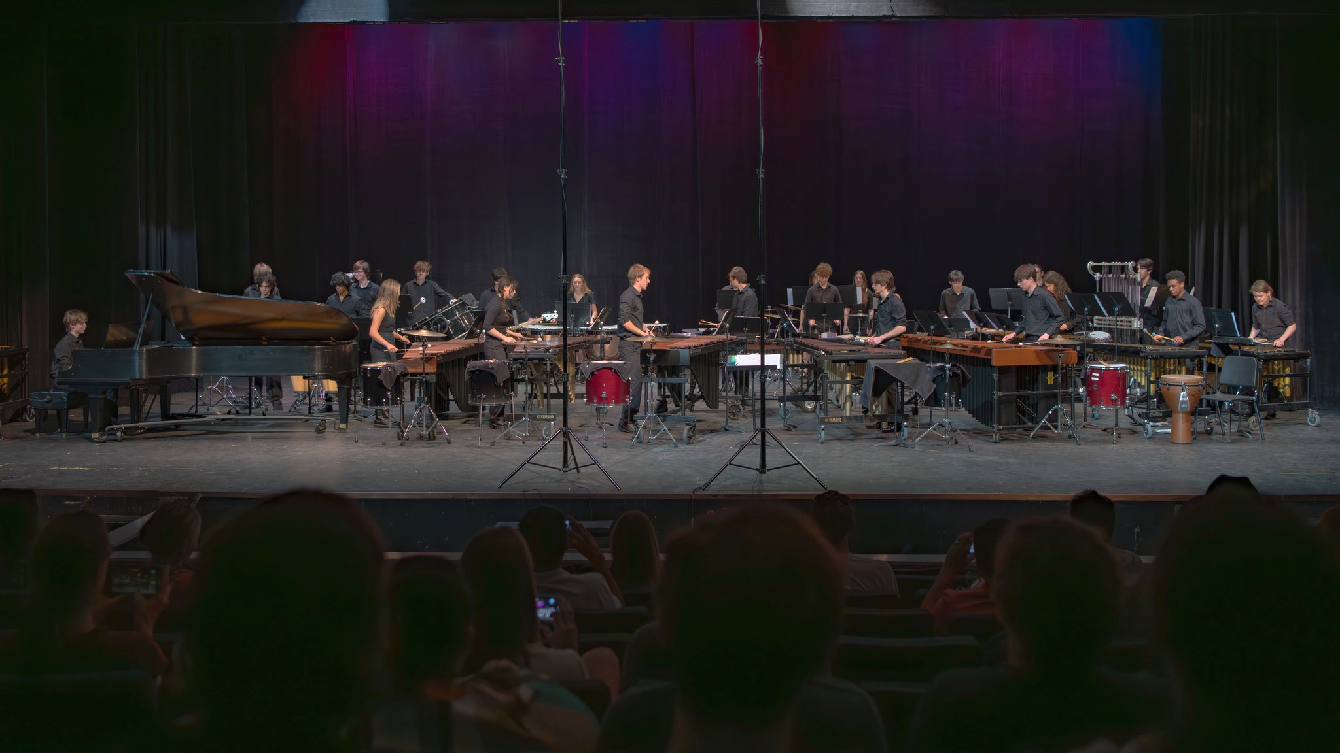

Welcome and thank you for registering for the Percussive Arts Society’s Percussion Ensemble Contest and Festival hosted by McCallum High School!
Since 2015, McCallum has hosted the Central Texas Percussion Festival in our beautiful McCallum Arts Center, providing a fantastic experience for students, educators, and the community. We’re so excited to be included in the PAS PECAF circuit and look forward to providing an even better opportunity for the musically rich and thriving percussion programs throughout the central Texas area and beyond.

Host contact info:
Ryan Pride
ryan.j.pride@austinisd.org
512-924-1915

In this packet you will find:
Detailed Map and Pathway Video
Adjudicator/Clinician information
List of instruments provided for the contest
Schedule with logistics (will be updated when entries are finalized)
Link to Announcer’s Script Submissions (will be updated when entries are finalized)

*Please be sure to bring scores of your performed works!*

Map - Unloading and Loading Logistics/Parking
Unloading will take place outside the north entrance of the McCallum Arts Center (MAC). Bring equipment through the double doors and stage/set up in the dance hallway (refer to video walkthrough). Medium sized equipment (vibraphones, xylos, glockenspiels, drums, etc.) can enter through the back stage door or the main entrance. Large instruments will go through the main entrance on to the performing stage (there will be students to help with this). Once your performance is finished, you’ll exit the stage through either the main entrance (big instruments) or door to backstage (small instruments) and exit the MAC through the south doors (two options) and load trucks in the faculty parking lot. Parking is available in the large lot along W. Koenig Ln, along the street on Sunshine Dr., and in the small faculty parking lot.
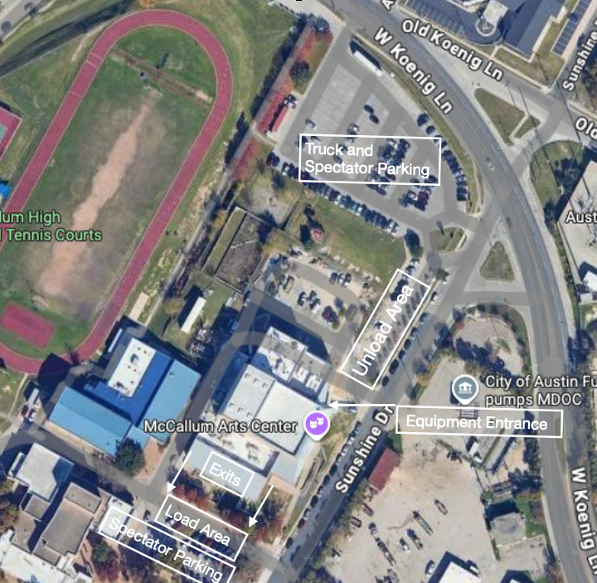

Path for unloading, performance, and loading. Video coming soon!

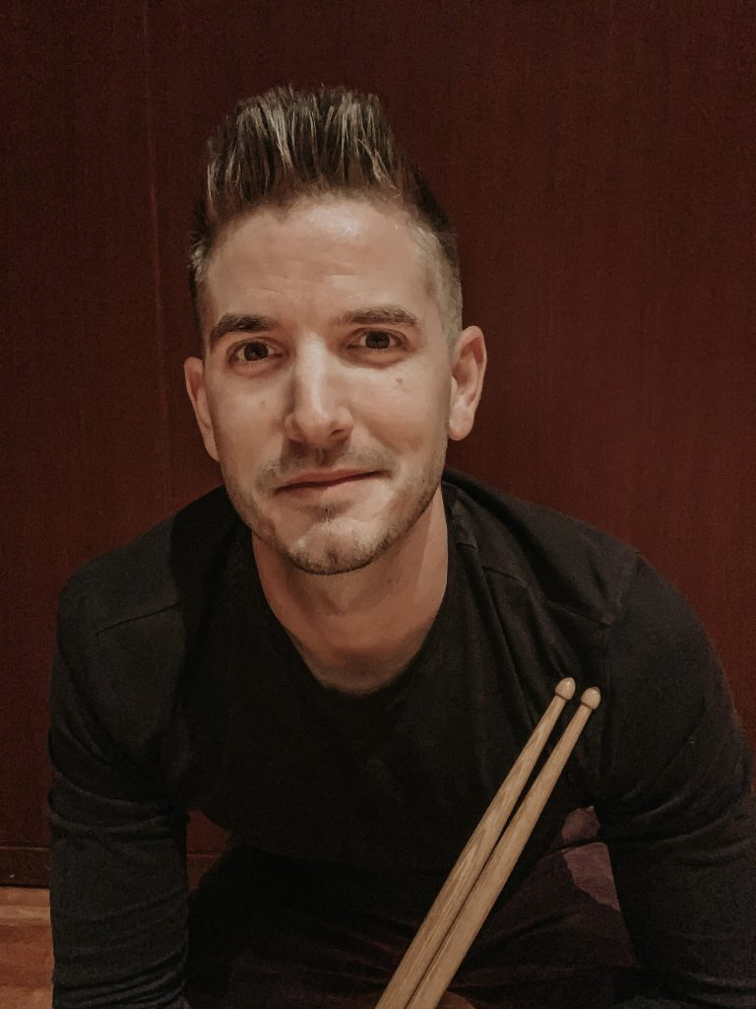
Adjudicators/Clinicians

Cory Doran
Dr. Cory Doran is currently an Instructor of Percussion and OU Bands Percussion Coordinator at the University of Oklahoma. Cory is a multi-faceted and energetic musician in the percussion community. He has commissioned and premiered various works for solo and ensemble percussion and continues to work with percussion and non-percussion composers to enhance and develop the percussion repertoire. Cory is an avid proponent for the evolution of electronics in percussion and the marching arts. He has given electronics clinics and masterclasses across the globe to engage audiences of all experience levels. Dr. Doran is passionate about creating an inclusive community of musicians who enjoy all styles and genres of music and percussion.
Previously, Dr. Doran held the position as Assistant Director of Percussion at Texas A&M University-Commerce (East Texas A&M) from 2017 to 2022 and Interim Professor of Percussion at Kent State University from 2016 to 2017. He has instructed throughout the mid-west and Texas as a front ensemble specialist as well as an orchestral percussion and drum set clinician. As a teacher, he has made a name for himself in the marching arts as a ensemble instructor for Matrix Indoor Marching Percussion Ensemble (2009- 2017), Front Ensemble Coordinator for the Phantom Regiment Drum and Bugle Corps (2015- 2022), and Glassmen Drum and Bugle Corps (2009-2011).
In tandem with his involvement in education, Cory is a dynamic performer and
composer/arranger. He has been a freelance marching percussion music designer for Cory Doran Music, Ferguson Design Solutions and Integrated Effects arranging companies and continues to compose and arrange for marching bands throughout the US. Cory has been a featured performer and clinician for high school, collegiate and independent groups in Italy, Taiwan, Belgium, Poland and throughout the continental United States. Recently, Cory was a featured clinician and performer at the Varna International Music Festival in Columbia, South Carolina.
Cory Doran completed a DMA in Percussion Performance (2025) at Michigan State
University under the direction of Professor Gwendolyn Dease and Dr. Jon Weber. Cory received his Masters degree (2011) in Music Performance from Texas A&M University-Commerce under the instruction of Dr. Brian Zator and his Undergraduate degree (2009) in Music Performance from Youngstown State University under the instruction of Dr. Glenn Schaft.
Cory is a proud endorser of Majestic Percussion, Mapex Drums, Innovative Percussion and
Sabian Cymbals.

Robert A. (Bobby) López
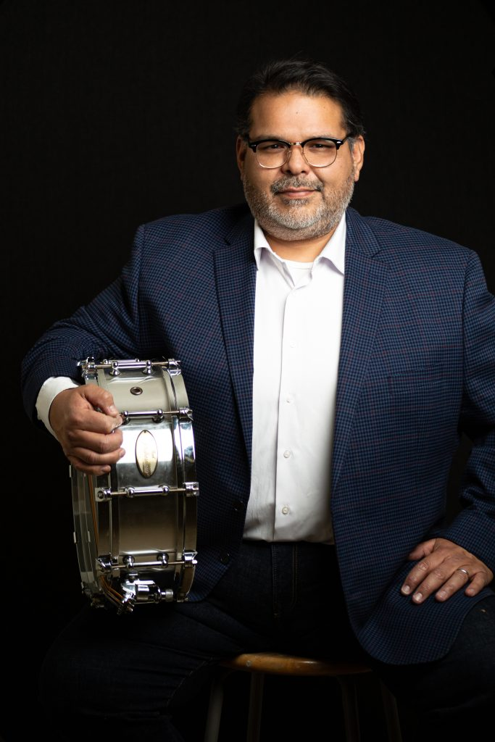
Robert A. (Bobby) López is currently Professor of Instruction at Texas State University and the marching percussion coordinator for the Bobcat Marching Band. His appointment includes teaching percussion methods, applied percussion, concert percussion ensemble, teaching the
percussion section of the Bobcat Marching Band and maintaining all percussion instruments for the Texas State University School of Music.
Mr. López is an active educator, clinician, performer and adjudicator throughout the United States. He attended Del Mar College in Corpus Christi, TX., received a Bachelor of Music degree in Music Education from Texas A&M University-Corpus Christi and a Master of Music degree in Percussion Performance from Texas State University. His teachers include Dr. Norman Weinberg, Dr. Paul Bissell, Genaro Gonzalez, Jim Casella, Murray Gusseck, Dave Sankus, Jeff Lee and Scott Johnson.
Bobby has worked with several high schools and middle schools in Texas and has adjudicated several contests and festivals such as the Lost Pines Marching Festival, Dripping Springs Marching Contest, Spring Percussion Festival, McCallum High School Percussion Festival and the Texas UIL State Solo & Ensemble Contest.
Mr. López has had students participate in various performing ensembles throughout the United States such as the Santa Clara Vanguard, Phantom Regiment, The Cadets, Boston Crusaders, The Crossmen, The Bluecoats, VIP Indoor, Rhythmic Force Indoor and Monarch Indoor. He also maintains a private percussion studio focusing on the development of young percussionists. His
private students have earned chairs in the Texas All-State ensembles, earned Outstanding Soloist at the Texas UIL Solo & Ensemble competition, earned chairs in the middle school region bands, and have participated in music festivals such as the Interlochen Summer Music Festival and YoungArts.
Aside from his duties at Texas State University, Bobby has performed as a regular extra in the Austin Symphony Orchestra since 2005. He continues to perform with ASO, Austin Opera and Ballet Austin. He has also performed with the Mid-Texas Symphony and Corpus Christi Symphony Orchestra. He is published by Tapspace Publications and is an endorser for Innovative Percussion, SABIAN Cymbals, Grover Pro Percussion.

Available Instruments provided by McCallum
Keyboards
2 Five Octave Marimba One marimbas
1 Low F Yamaha Acoustalon marimba on a field frame
1 Low A Marimba One Rosewood marimba on a wave frame
3 Low A Yamaha Acoustalon marimbas on field frames
4 Yamaha vibraphones (3 octaves)
2 Yamaha Rosewood Xylophones
1 Yamaha 3.3 Octave Pedal Glockenspiel (C-E)l
1 Fall Creek Glockenspiel
2 Deagan Glockenspiels
1 Degan Chimes
1 two octave set of Zildjian crotales

Drums
3 concert bass drums (1 Adams [36”] and 2 Ludwig [36” and 40”])
2 concert snare drums (1 Pearl 14x5 and 1 Black Swamp 14x5)
1 sets of six Pearl concert toms (graduated sizes)
1 set of four Ludwig concert toms (graduated sizes)
2 sets of congas
2 set of bongos
1 Yamaha Custom drumset
1 set of five Adams Timpani (all gauges functional)
1 set of five Yamaha Timpani (all gauges functional except 23”)

Metals
6 suspended cymbals
4 sets of crash cymbals
2 china cymbals
1 ride cymbal
1 tam-tam (40”)

If you have any special requests, please let us know by Friday, April 17th. We’ll do our best to accommodate!

Logistic Schedule - coming soon!

